SPONSORSHIP FORM 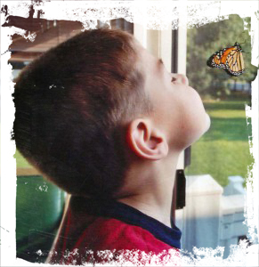
Name of Fundraiser: ____________________________________________________ Event: ______________________________________________
Contact: ___________________________________________ Address: _______________________________________________________________________
Name | Address | Town | Zip code | Amount  Pledged | Amount  Paid | Gift Aid? | Signature
AHC is a rare neurological disorder in which repeated, transient attacks of hemiplegia (paralysis of a portion of the body, including the face) occur, usually affecting one side of the body or the other, or both sides of the body at once. It ranges from simple numbness in an extremity to full loss of feeling and movement. The attacks may last for minutes, hours or even days and are normally relieved by sleep. Triggers for AHC episodes may include–but are not limited to–environmental conditions (such as temperature extremes or odors), water exposure, physical activities (exercise, swinging), lights (sunlight, fluorescent bulbs), foods (chocolate, food dye), emotional response (anxiety, stress, fright), odors (foods, fragrances), fatigue, and medications.
http://ahckids.org/

